[ Insert official UPAEP logo ]
UPAEP · Decanato de Ingenierías
EVIDENCE — US25-T3
Implement register, edit and deactivate
SmartGreenAI: Cilantro Crop

1. Task information
Task ID | US25-T3
User Story | US-25 — Register IoT devices, sensors and actuators
Sprint | Sprint 2 (2026-09-21 – 2026-10-09)
Week | Week 2
Responsible | Alexis Enrique Valle Parra
Peer reviewer | Jorge Velez Delgado
Planned / actual hours | 3 h / 3 h
Completed on | October 2, 2026
Status | Done

2. Task description
Implement the logic for registering, editing and deactivating (not deleting) devices, sensors and actuators, with unique IDs and Administrator-only access.

3. Completion conditions
✓ Condition 1: Devices, sensors and actuators can be registered, edited and deactivated.
How it was verified: A device, a sensor and an actuator were registered (201, 201, 201), edited (200, 200) and deactivated (200, 200, 200).
Register, edit, deactivate (attached: US25-T3_Implement_Register_Edit_Deactivate_4.txt)
POST /api/devices
Authorization: Bearer eyJhbG…
{
"id": "dev-node-25a",
"name": "Node 25A",
"mac_address": "A4:CF:12:25:0A:01",
"greenhouse_id": "GH-01",
"area_id": "AREA-2"
}
→ HTTP 201 Created (20 ms)
{
"device_id": "dev-node-25a",
"id": "dev-node-25a",
"name": "Node 25A",
"mac_address": "A4:CF:12:25:0A:01",
"location": null,
"organization_id": "org-team3",
"greenhouse_id": "GH-01",
"area_id": "AREA-2",
"firmware": null,
… (9 more lines in the attached file)
POST /api/sensors
Authorization: Bearer eyJhbG…
{
"id": "SM-25A",
"device_id": "dev-node-25a",
"area_id": "AREA-2",
"name": "Soil probe 25A",
"type": "soil_moisture",
"unit": "%",
"physical_min": 0,
"physical_max": 100
}
→ HTTP 201 Created (23 ms)
{
"id": "SM-25A",
"device_id": "dev-node-25a",
"area_id": "AREA-2",
"name": "Soil probe 25A",
"type": "soil_moisture",
"unit": "%",
"physical_min": 0,
"physical_max": 100,
"is_active": true,
… (7 more lines in the attached file)
POST /api/actuators
Authorization: Bearer eyJhbG…
{
"id": "ACT-25A",
"device_id": "dev-node-25a",
"area_id": "AREA-2",
"name": "Pump 25A",
"type": "irrigation_pump"
}
→ HTTP 201 Created (14 ms)
{
"id": "ACT-25A",
"device_id": "dev-node-25a",
"area_id": "AREA-2",
"name": "Pump 25A",
"type": "irrigation_pump",
"state": "OFFLINE",
… (104 more lines)

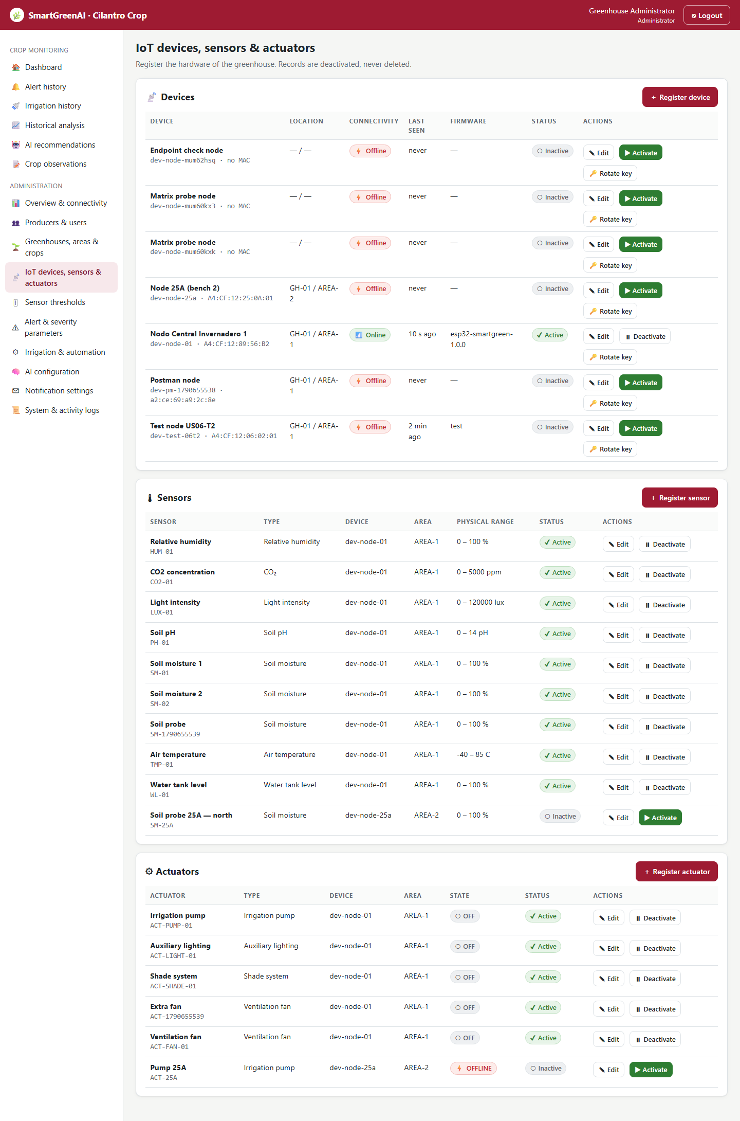
Figure US25-T3-1. Registry screen after the test: Node 25A, its sensor and its actuator are listed as Inactive with an Activate button. (US25-T3_Implement_Register_Edit_Deactivate_3.png)
✓ Condition 2: IDs are unique and records are deactivated, not deleted.
How it was verified: IDs are unique (a second SM-25A is refused with 409 ERR_CONFLICT); there is no delete: DELETE /devices/{id} answers 404 and the deactivated rows remain in the database.
Duplicate ID and delete attempt (attached: US25-T3_Implement_Register_Edit_Deactivate_5.txt)
POST /api/sensors
Authorization: Bearer eyJhbG…
{
"id": "SM-25A",
"device_id": "dev-node-01",
"area_id": "AREA-1",
"name": "Duplicate",
"type": "soil_moisture",
"unit": "%",
"physical_min": 0,
"physical_max": 100
}
→ HTTP 409 Conflict (9 ms)
{
"status": 409,
"code": "ERR_CONFLICT",
"message": "A sensor with id \"SM-25A\" is already registered.",
"details": []
}
DELETE /api/devices/dev-node-25a
Authorization: Bearer eyJhbG…
→ HTTP 404 Not Found (4 ms)
{
"status": 404,
"code": "ERR_RESOURCE_NOT_FOUND",
"message": "No API route matches DELETE /api/devices/dev-node-25a.",
"details": []
}

The records after the test: still in the database, deactivated (3 rows; US25-T3_Implement_Register_Edit_Deactivate_1.csv)
kind | id | name | is_active
device | dev-node-25a | Node 25A (bench 2) | false
sensor | SM-25A | Soil probe 25A — north | false
actuator | ACT-25A | Pump 25A | false
SQL: SELECT 'device' AS kind, id, name, is_active FROM devices WHERE id = 'dev-node-25a' UNION ALL SELECT 'sensor', id, name, is_active FROM sensors WHERE id = 'SM-25A' UNION ALL SELECT 'actuator', id, name, is_active FROM actuators WHERE id = 'ACT-25A'
✓ Condition 3: Only Administrators can perform these actions.
How it was verified: Only Administrators can do it: the Producer receives 403 for register, edit and deactivate (403, 403, 403).
Producer attempts (attached: US25-T3_Implement_Register_Edit_Deactivate_6.txt)
POST /api/devices
Authorization: Bearer eyJhbG…
{
"name": "x"
}
→ HTTP 403 Forbidden (8 ms)
{
"status": 403,
"code": "ERR_INSUFFICIENT_PERMISSIONS",
"message": "Your role (Producer) does not allow this operation.",
"details": [
{
"field": "permission",
"issue": "Missing permission: devices.write"
… (3 more lines in the attached file)
PUT /api/sensors/SM-01
Authorization: Bearer eyJhbG…
{
"name": "x"
}
→ HTTP 403 Forbidden (7 ms)
{
"status": 403,
"code": "ERR_INSUFFICIENT_PERMISSIONS",
"message": "Your role (Producer) does not allow this operation.",
"details": [
{
"field": "permission",
"issue": "Missing permission: sensors.write"
… (3 more lines in the attached file)
PUT /api/actuators/ACT-PUMP-01
Authorization: Bearer eyJhbG…
{
"is_active": false
}
→ HTTP 403 Forbidden (8 ms)
{
"status": 403,
"code": "ERR_INSUFFICIENT_PERMISSIONS",
"message": "Your role (Producer) does not allow this operation.",
"details": [
{
"field": "permission",
"issue": "Missing permission: actuators.write"
… (3 more lines in the attached file)

✓ Condition 4: Evidence: Records are created, edited and deactivated correctly.
How it was verified: Records are created, edited and deactivated correctly (table and screenshot).

4. Attached files
- US25-T3_Implement_Register_Edit_Deactivate_1.csv
- US25-T3_Implement_Register_Edit_Deactivate_2.sql
- US25-T3_Implement_Register_Edit_Deactivate_3.png
- US25-T3_Implement_Register_Edit_Deactivate_4.txt
- US25-T3_Implement_Register_Edit_Deactivate_5.txt
- US25-T3_Implement_Register_Edit_Deactivate_6.txt

5. Traceability
Related requirements | FR-05, FR-06, FR-07, NFR-02, NFR-09
Implementation | See docs/TRACEABILITY.md
Verification | See docs/TRACEABILITY.md

6. Sign-off
Role | Name | Date | Signature
Responsible | Alexis Enrique Valle Parra | October 2, 2026
Peer reviewer | Jorge Velez Delgado | October 2, 2026
Product Owner acceptance | Alexis Enrique Valle Parra | October 2, 2026

